Mother Teresa Catholic School

Presents the Twelfth Annual

Spook-a-Thon, Dance-a-Thon

October 31, 2018
Dear Parents & Guardians:

Our Thirteenth annual Spook-a-Thon, DANCE-A-THON is our children’s major school fundraising event; the funds collected go to support student agendas, spirit events, and special occasions such as First Communion, Confirmation and Graduation. Every year the Mother Teresa School Council also commits a portion of the funds to school enhancements.

Spook-a-Thon Pledges
We are asking students to obtain pledges from family and friends. We would like to remind you of our policy that students are not to go door to door seeking pledges. It would be helpful if pledges could be collected at the time they are made. More pledge sheets will be available at the school if required.

We would like to advise you of the following procedures to ensure that the event runs smoothly:

- All students are asked to return their pledge sheets and money to the school on Wednesday, October 31, 2018. Money must be brought in the collection envelope. If you have more than one child collecting pledges, please ensure that each child uses their own envelope with their name, and teachers name on the front.
- Please ensure all pledge sheets (with your child’s name) and money is returned by October 31, 2018.
- There are only two ways to send pledges in this year:
- Cash
2. One cheque for the total on the pledge sheet payable to Mother Teresa Catholic School. The office can not accept multiple cheques and cash for each pledge sheet (it will be returned if sent this way.
- All unused pledge sheets must be returned to the school.
- Our volunteer committee will coordinate all pledge sheets, money and prize incentive raffle tickets.

Spook-a-Thon Incentive Prizes
We are proud of the great incentive prizes we have received. Our school community has been generous with their donations.

Raffle Prizes
- Your child will be awarded a raffle ticket for a prize for each $5.00 in pledges received. Soon the children will be able to look in the display case in the hallway to see the great prizes; new additions are being added daily!
- Money and pledge sheets must be received by Wednesday, October 31, 2018, to have children’s names entered in the raffle draws for incentive prizes. Your child’s raffle tickets will be drawn after his/her pledge sheet is received.

Awarded Prizes
- There will be prizes awarded for:
The Highest Overall Pledges
The Highest Class Pledges
& the Highest Pledges for each school division

Thank You
On behalf of the students of Mother Teresa Catholic School, the committee members of the Spook-a-Thon Fundraiser, and parents and staff,
we graciously thank you for your support.

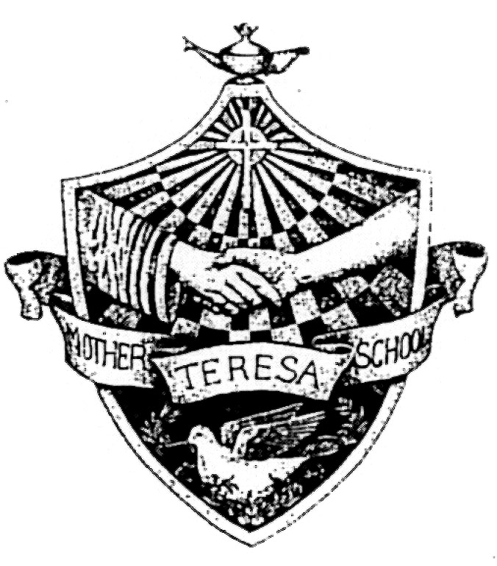
Mother Teresa Catholic School Council
1044 Lancaster Drive, Kingston, Ontario 613-384-8644
SPOOK-A-THON Dance-a-thon – Wednesday, October 31, 2018

**PROCESS FOR PLEDGE COLLECTION**
- Send in ONE CHEQUE for the total on the pledge sheet payable to Mother Teresa Catholic School OR
- Cash only (no cheques).
The office cannot accept multiple cheques and cash for each pledge sheet (it will be returned if sent in this way).

Student Name ____________________________________ Teacher __________________________
PLEDGE: I pledge to dance to help raise funds for Mother Teresa Catholic School on Wednesday, October 31, 2018
 | Name | Address | Phone Number | Amount Pledged | Payment |  | Amount Received
 |  |  |  |  | Cash | Cheque | Amount Received
1
2
3
4
5
6
7
8
9
 |  | TOTAL PLEDGES  ONE CHEQUE ATTACHED or  CASH ENCLOSED FOR: |  | $
All pledge sheets must be brought to school
on the day of the Spook-a-thon, Wednesday, October 31, 2018

